**MVC概念**

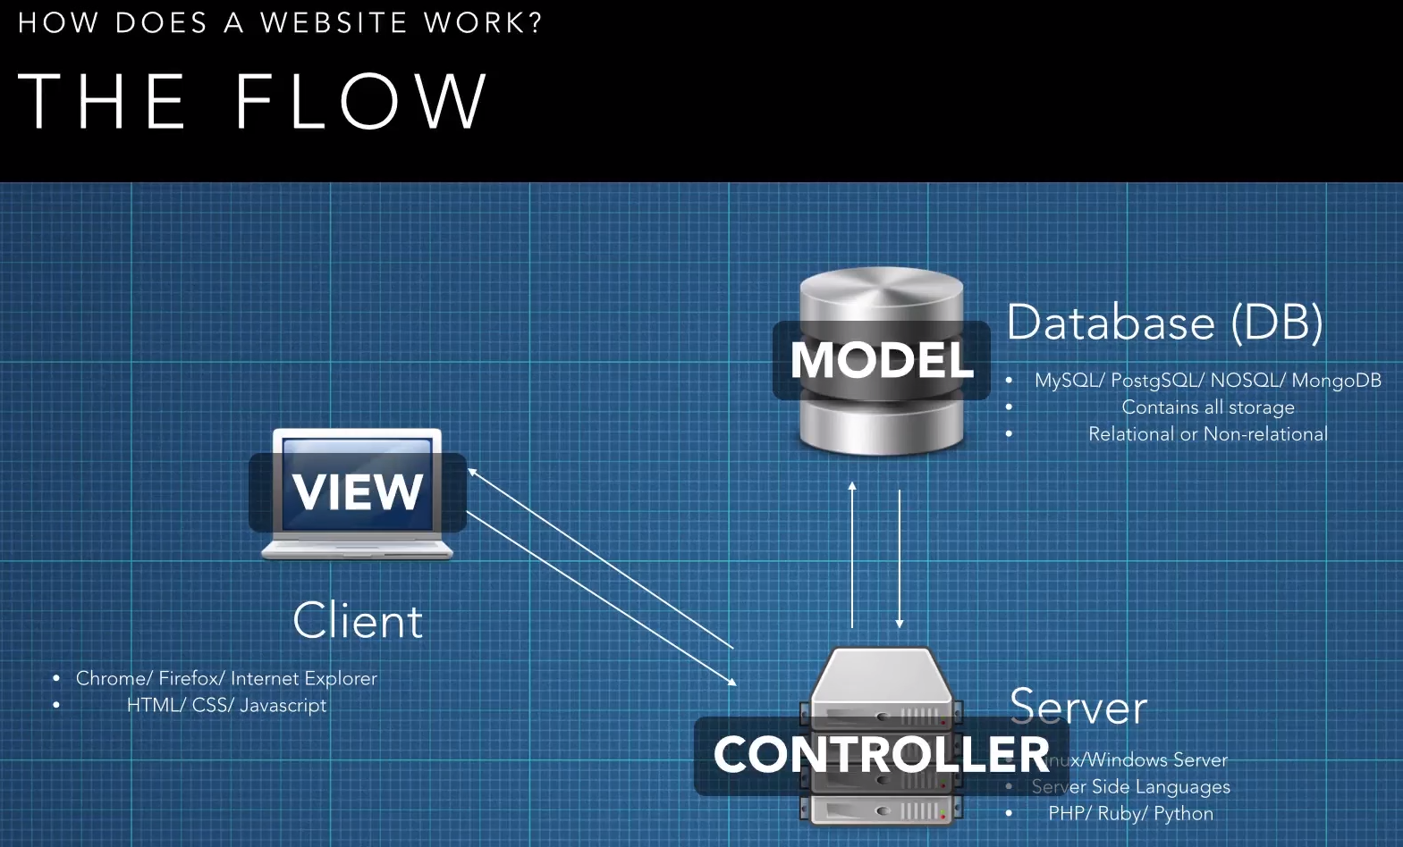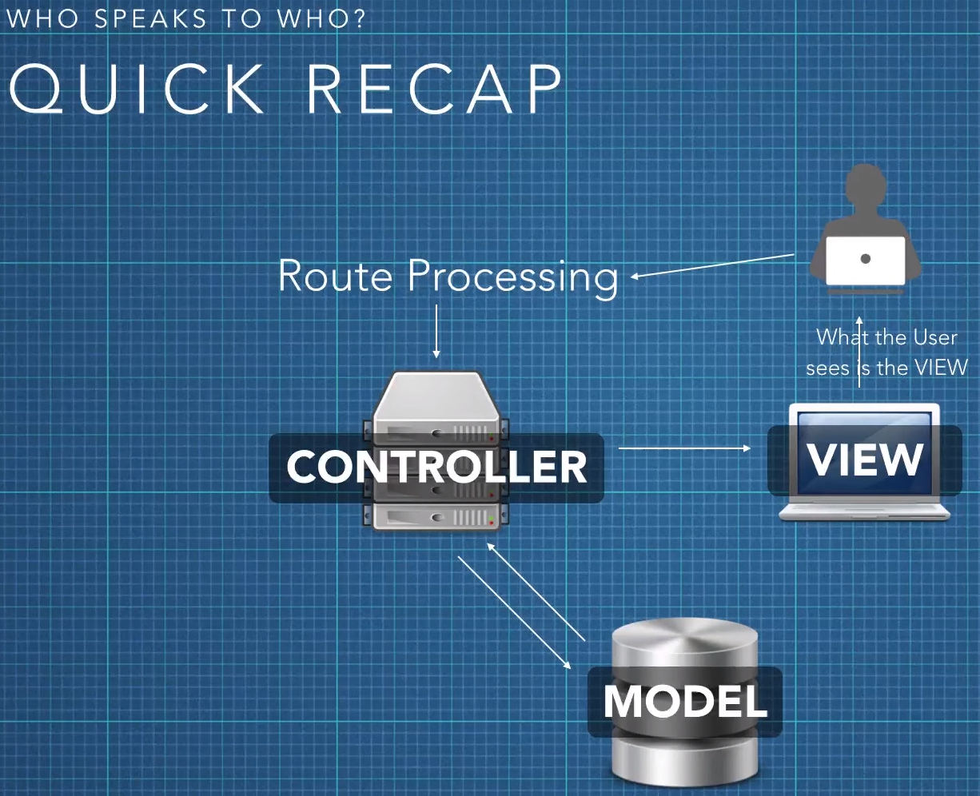

<https://www.youtube.com/watch?v=1IsL6g2ixak>